Master Functional Document

Application | NGERP - Centra
Service Bundle | Master Management
Service Request | Sales Type

Description :

Sale Type is used to categories document type by sales category .

Workflow Process :

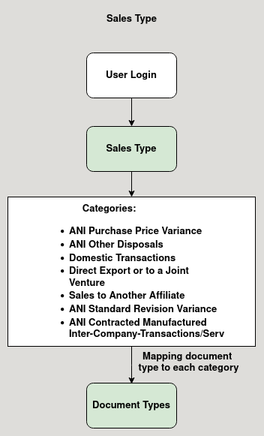

Business Rules :

- User can use this master to categories document type.
- There are 7 categories in sales type.

  - ANI Purchase Price Variance
  - ANI Other Disposals
  - Domestic Transactions
  - Direct Export or to a Joint Venture
  - Sales to Another Affiliate
  - ANI Standard Revision Variance
  - ANI Contracted Manufactured Inter-Company-Transactions/Ser

